**DBMS Laboratory**

**UE19CS304**

**5th Semester, Academic Year 2021-22**

Week #: 8 - Joins: inner,outer; Sub Queries Date: 6/11/2021

|  |  |  |
| --- | --- | --- |
| Name :  SUMUKH RAJU BHAT | SRN :  PES1UG19CS519 | Section :  H |

1. Using nested query retrieve the names of all employees who have two or more dependents.

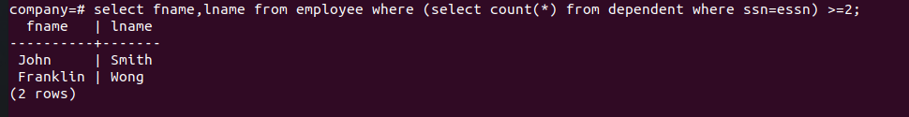

1. Using nested query Retrieve the name of each employee who has a dependent with the same first name and is the same sex as the employee.



1. Using nested query retrieve names of employees whose salary is greater than the salary of all the employees in department 5.

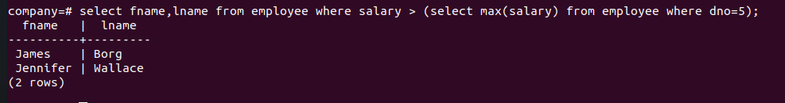

1. Retrieve the names of employees who have no dependents.( use Exists/Not Exists)

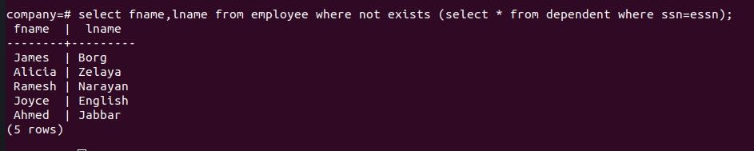

1. List the names of managers who have at least one dependent.



1. Using natural Join retrieve the name and address of every employee who works for the Research department

